Name: B.Vinayani
Registration Number: 192472179

EXPERIMENT 5
Zero-shot, One-shot and Few-shot Prompts - Promotional Social Media Post for an AI Workshop

AIM
To design zero-shot, one-shot and few-shot prompts for generating a promotional social media post for an AI Workshop and to observe the effect of examples on style and engagement.

PROCEDURE
1. Open an LLM chat interface (such as ChatGPT, Gemini or Claude) in a new chat.
2. Zero-shot: enter an instruction that describes only the task (generate a promotional social media post for an AI Workshop) without any example, and note the response.
3. One-shot: start a new chat and enter the same instruction together with ONE worked example, followed by the actual task. Note the response.
4. Few-shot: start a new chat and enter the same instruction together with THREE worked examples, followed by the actual task. Note the response.
5. Capture a screenshot of each prompt with its generated output.
6. Compare the three outputs and record the observations.

PROMPTS (CODE)
Zero-shot prompt:
Generate a promotional social media post for an AI Workshop.

One-shot prompt:
Write a promotional social media post for an AI Workshop in the same style as the example.

Example:
Level up your code! Join our 2-day Python Bootcamp
Date: 10-11 March | Venue: Lab 3
- Hands-on projects
- Certificate for all
Seats are limited - register today!
#Python #Coding #Bootcamp

Now write the post for: AI Workshop | Date: [Date] | Venue: [Venue]

Few-shot prompt:
Write a promotional social media post for an AI Workshop in the same style as the examples.

Example 1:
Level up your code! Join our 2-day Python Bootcamp
Date: 10-11 March | Venue: Lab 3
- Hands-on projects
- Certificate for all
Seats are limited - register today!
#Python #Coding #Bootcamp

Example 2:
Is your data safe? Find out in our Cyber Security Webinar
Date: 22 April | 6 PM | Online
- Live demos by industry experts
- Q&A session
Reserve your spot now!
#CyberSecurity #Webinar #StaySafe

Example 3:
Build. Break. Win. The Web Dev Hackathon is here
Date: 5 May | Venue: Innovation Hub
- 24 hours of coding
- Exciting prizes
Form your team and sign up today!
#Hackathon #WebDev #Innovation

Now write the post for: AI Workshop | Date: [Date] | Venue: [Venue]

OUTPUT
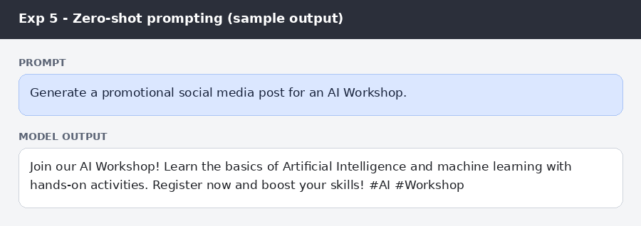
Figure: Zero-shot prompt and sample post
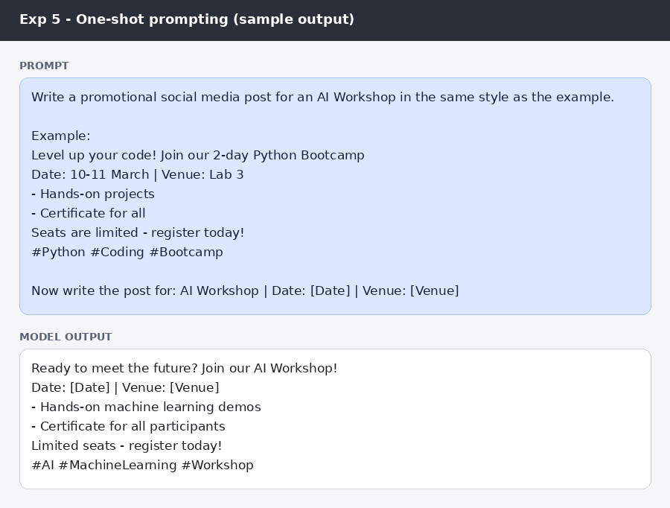
Figure: One-shot prompt and sample post
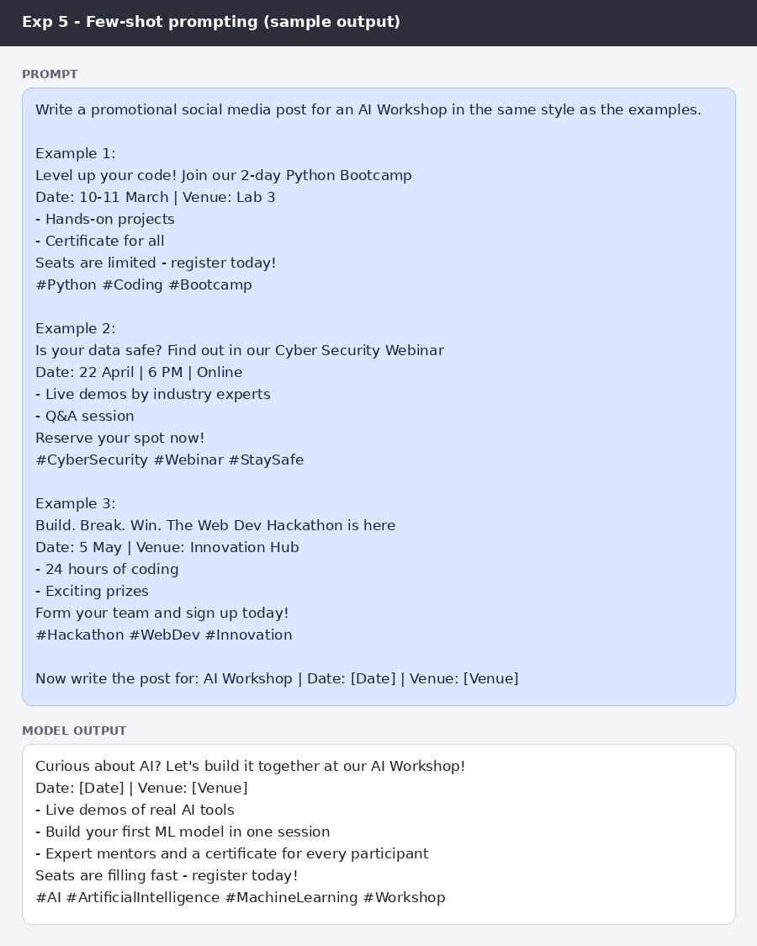
Figure: Few-shot prompt and sample post

RESULT
The zero-shot post was short and generic, with a general call to register. The one-shot post copied the example's hook, date and venue line, bullet highlights, urgency line and hashtags. The few-shot post was the most engaging: it used a curiosity-based hook, three specific benefits, a stronger urgency line and a richer set of hashtags in the same style as the examples.

CONCLUSION
Examples teach the LLM the tone and layout of a promotional post. Few-shot prompting produced the most engaging and consistent social media post, so it is the best choice when a brand style must be followed.

